 [Translated from Spanish to English - www.onlinedoctranslator.com](https://www.onlinedoctranslator.com/en/?utm_source=onlinedoctranslator&utm_medium=docx&utm_campaign=attribution)



**Web 5.0 network camera**

**Operation Manual**

ZHEJIANG DAHUA VISION TECHNOLOGY CO., LTD. V1.0.0

# Foreword

General

This manual covers the functions, configuration, general operation and maintenance of the network camera system.

Security instructions

The following classified signal words with a defined meaning may appear in the manual.

| **Signal words** | **Meaning** |
| --- | --- |
| WARNING | Indicates a medium or low potential risk which, if not avoided, could result in minor or moderate injury. |
| CAUTION | Indicates a potential hazard that, if not avoided, could result in property damage, loss of data, poor performance, or other unpredictable results. |
| TIPS | Provides methods to help you solve a problem or save time. |
| NOTE | Provides additional information as emphasis or complement to the text. |

Revision history

| **Version** | **Review content** | **Release date** |
| --- | --- | --- |
| V1.0.0 | First launch. | October 2020 |

About the manual

* The manual is just a reference. If you detect any discrepancy between the manual and the actual product, the actual product shall prevail.
* We will not accept any responsibility for losses caused by using the device without following the instructions in the manual.
* The manual will be updated in accordance with the latest laws and regulations of related jurisdictions. For more information, please refer to the printed manual, CD-ROM, QR code or our official website. In the event of a discrepancy between the printed manual and the electronic version, the electronic version will prevail.
* All designs and software contained herein are subject to change without prior written notice. Product updates may cause discrepancies between the actual product and the manual. Contact customer service requesting the updated program and supplemental documentation.
* There may still be some deviations in technical data, functions and description of operations, or printing errors. If there is any doubt or controversy, we reserve the right to final explanation.
* Please update the reader software or try other conventional reader software in case you cannot open the manual (in PDF format).
* All trademarks, registered trademarks and company names in the manual are the property of their respective owners.
* Please visit our website, contact your seller or customer service if you have problems using the device.
* If there are uncertainties or disputes, we reserve the right to final explanation.

# Important Safety Warnings and Precautions

Electrical safety

* All instructions for use and installation must comply with the electrical safety regulations of your country.
* The power supply must comply with the Safety Low Voltage (SELV) standard and supply power with a nominal voltage that meets the limited power supply requirement in accordance with IEC60950-1. Power supply requirements are indicated on the device label.
* Make sure the power supply is adequate before using the device.
* An easily accessible disconnect device must be incorporated into the building installation wiring.
* Avoid pinching or pinching the power cord, especially at the connector, outlet, and where it exits the device.

Operating environment

* Do not point the device directly at strong light when focusing, such as lamplight and sunlight; Otherwise, it may cause excessive glare or light marks, which will not be caused by device malfunction, and may affect the life of the complementary metal oxide semiconductor (CMOS).
* Do not place the device in a humid, dusty, extremely hot or cold environment, or in places with strong electromagnetic radiation or unstable lighting.
* Keep the device away from any liquid to prevent damage to the internal components.
* Keep the indoor device away from rain or moisture to avoid fire or lightning.
* Maintain good ventilation to avoid heat buildup.
* Transport, use and store the device within the permitted limits of humidity and temperature.
* Do not subject the unit to high pressure, strong vibration or splashing water during transportation, storage and installation.
* When transporting the device, keep it in the factory packaging or use equivalent materials.
* Install the device in a location that can only be accessed by professional personnel with appropriate knowledge of safety protections and warnings. Otherwise, injury may occur to non-professionals entering the installation area when the device is operating normally.

Daily use and maintenance

* Do not touch the heat dissipation component of the device to avoid burns.
* Carefully follow the instructions in the manual when performing any disassembly operations on the device; Otherwise, it may cause water leakage or poor image quality due to unprofessional disassembly. Please contact after-sales service to replace the desiccant if there is condensed fog on the lens after taking the product out of the box or if the desiccant turns green. (Not all models include desiccant).
* It is advisable to use the device together with a lightning rod, to improve the lightning protection effect.
* It is recommended to ground the device to improve reliability.
* Do not touch the image sensor (CMOS) directly. Dust and dirt can be removed with an air blower, or you can wipe the lens gently with a soft cloth moistened with alcohol.
* You can clean the device case with a soft, dry cloth, and for more stubborn stains, use the cloth with a mild detergent. To avoid possible damage to the coating of the device's case that could result in decreased performance, do not use volatile solvents such as alcohol, benzene, turpentine, etc., to clean the device's case, nor can you use a strong, abrasive detergent. .
* The domed cover is an optical component. Do not touch or clean the cover with hands directly during installation or operation. To remove dust, grease, or fingerprints, wipe gently with an oil-free cotton swab moistened with diethyl or a soft, damp cloth. You can also remove dust with an air blower.

**WARNING**

* Strengthen the protection of your network, device data, and personal information by taking measures including, but not limited to, using strong passwords, changing passwords regularly, updating firmware to the latest version, and isolating of the computer network. For some devices with old firmware versions, the ONVIF password will not be changed automatically along with the system password change, and you will need to update the firmware or manually update the ONVIF password.
* Please use components or accessories supplied by the manufacturer and ensure that professional engineers carry out the installation and maintenance of the device.
* The surface of the image sensor should not be exposed to laser beam radiation in an environment where a laser beam device is used.
* Do not provide two or more power supplies for the device unless otherwise specified. Failure to follow these instructions could damage the device.

Index of contents

Foreword Yo

Important Safety Warnings and Precautions III

1 Overview 1

1.1 Introduction 1

1.2 Network connection 1

1.3 Configuration flow 1

2 Device initialization 3

3 Access 7

3.1 Sign in to the device 7

3.2 Reset your password 8

4 Straight 10

4.1 Live Interface 10

4.2 Encoding settings eleven

5 Settings 12

5.1 Grid 12

5.1.1 TCP/IP 12

5.1.2 Port fifteen

5.1.3 Email 17

5.1.4 Basic service 19

5.2 Event twenty

5.2.1 Alarm input configuration twenty-one

5.2.2 Set alarm linkage 22

5.2.2.1 Add schedule 23

5.2.2.2 Recording Link 24

5.2.2.3 Linking snapshots 25

5.2.2.4 Alarm output linkage 25

5.2.2.5 Email Linking 26

5.3 System 26

5.3.1 General 26

5.3.1.1 Essential 26

5.3.1.2 Date and Time 27

5.3.2 Account 28

5.3.2.1 User 28

5.3.2.1.1 Add users 28

5.3.2.1.2 Reset your password 31

5.3.2.2 ONVIF user 32

5.3.3 Managers 33

5.3.3.1 Requirements 33

5.3.3.2 Maintenance 3. 4

5.3.3.3 Import Export 35

5.3.3.4 Predetermined 35

5.3.4 Update 36

Appendix 1 Cybersecurity recommendations 37

# Overview

## Introduction

An IP camera (Internet Protocol Camera) is a type of digital video camera that receives control data and sends image data over the Internet. They are commonly used for surveillance and do not require a local recording device, but only a local area network.

IP camera is divided into single-channel camera and multi-channel camera according to the number of channels. For multi-channel camera, you can set parameters for each channel.

## Network connection

In the general IP Camera (IPC) network topology, the IPC connects to the PC through a network switch or router.

Figure:general IPC network

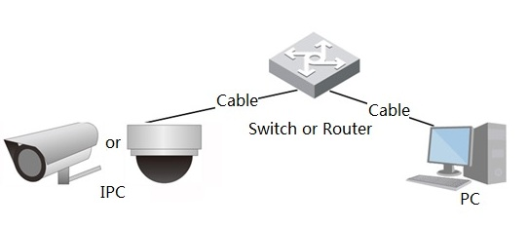

PC

Wire

Switch or router

Wire

either

CPI

Get the IP address by searching ConfigTool and then you can start accessing the IPC over the network.

## Configuration flow

For more information, seeFigure 1:2. For details, seeTable 1:1. Please configure the device according to the actual situation.

Figure:configuration flow

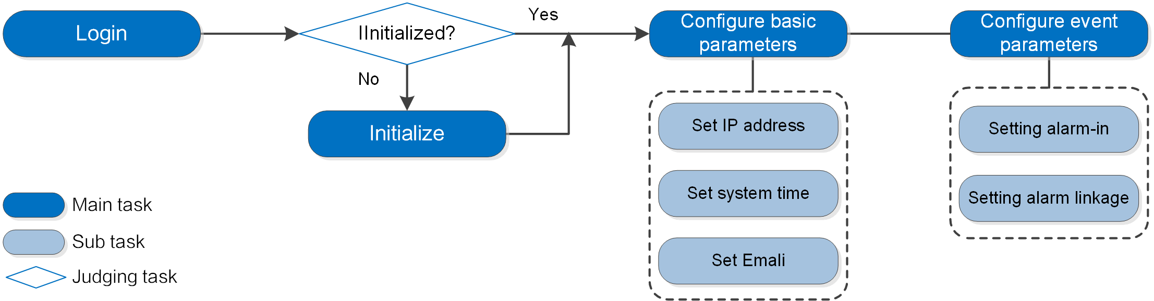

Set alarm linkage

Yeah

No

It has started?

Alarm input configuration

Set email

Set system time

Set IP address

Configure event parameters

Configure basic parameters

Initialize

Access

Main task

Secondary task

Evaluation task

Board:flow description

| **Setting** | | **Description** | **Reference** |
| --- | --- | --- | --- |
| Access | | Open IE browser and enter the IP address to log in to the web interface. The IP address of the camera is 192.168.1.108 by default. | "‎3 Access". |
| Initialization | | Please start the camera when you use it for the first time. | "‎2 Device initialization" |
| Basic parameters | IP adress | Change the IP address according to network planning when using the product for the first time or during network setup. | "‎5.1.1 TCP/IP" |
| Date and Time | Set the date and time to ensure the recording time is correct. | "‎5.3.1.2 Date and Time" |

# Device initialization

It is necessary to start the device for the first use. This manual is based on the operation of the web interface. You can also boot the device via ConfigTool or NVR.



* To ensure the security of the device, please keep the password correctly after startup and change it regularly.
* When starting the device, keep the PC IP and the device IP on the same network.

Step 1:Open the Chrome browser, enter the device's IP address in the address bar, and then press the Enter key.



The IP is 192.168.1.108 by default.

Figure:region settings

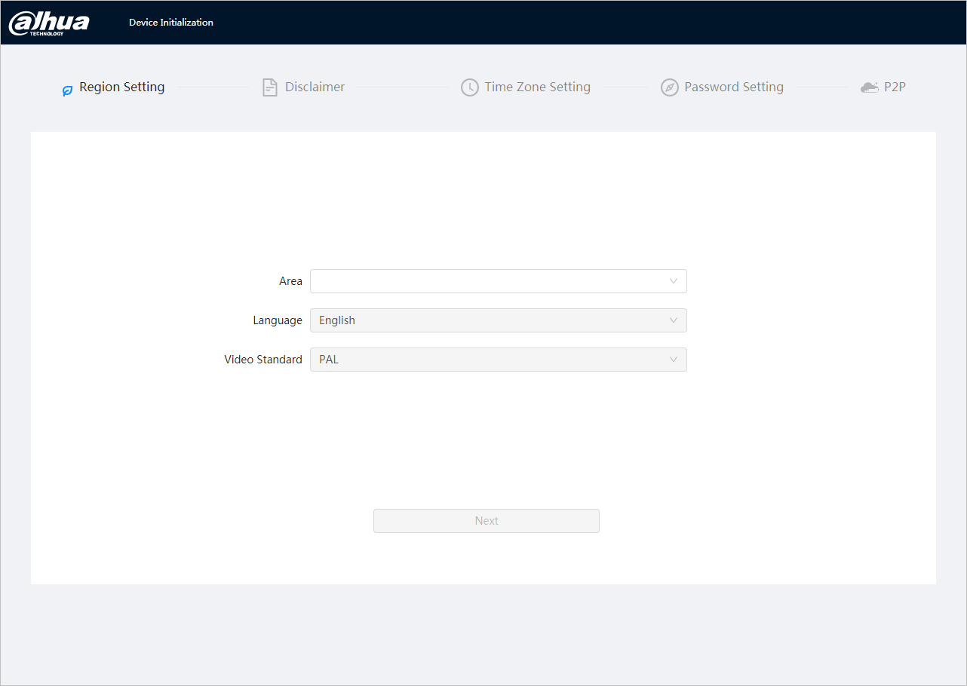

Step 2:Select the area, language and video standard according to the actual situation, and then click Next.

Figure:disclaimer

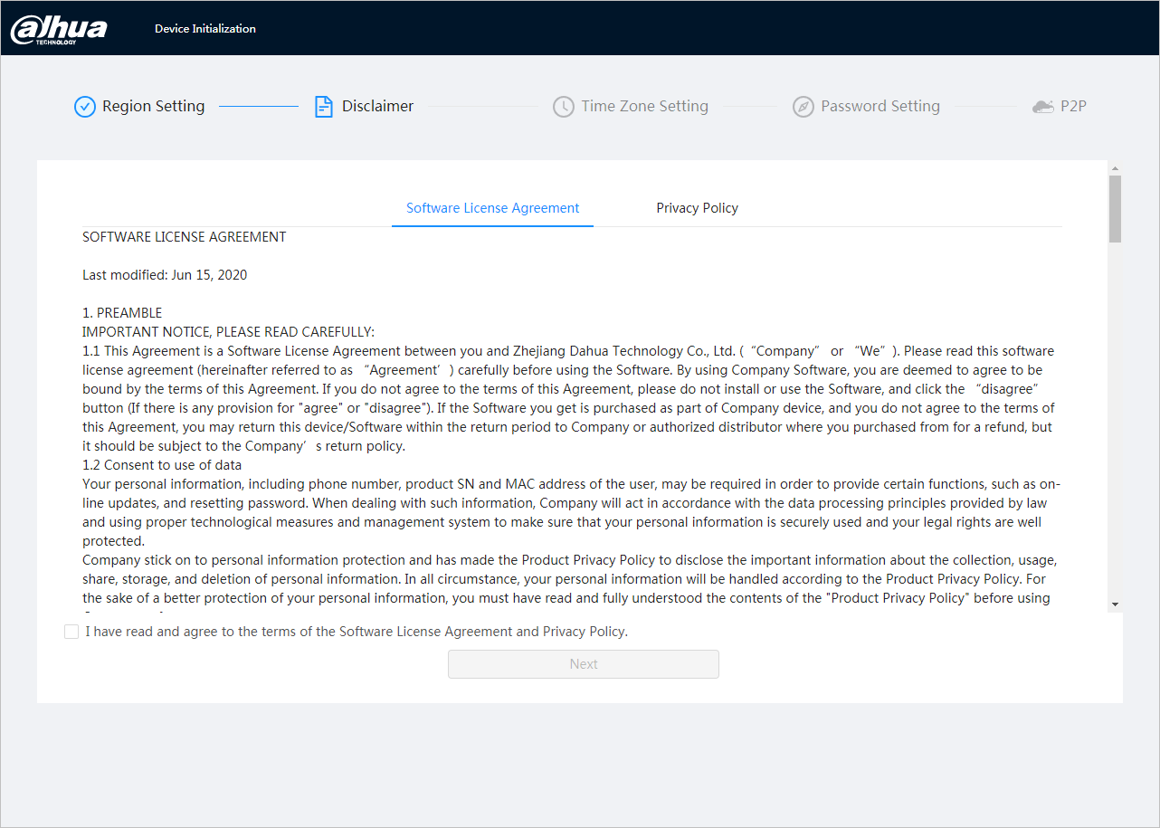

Step 3:Select the I have read and agree to the terms of the Software License Agreement and Privacy Policy check box, and then click Next ( Next).

Figure:time zone settings

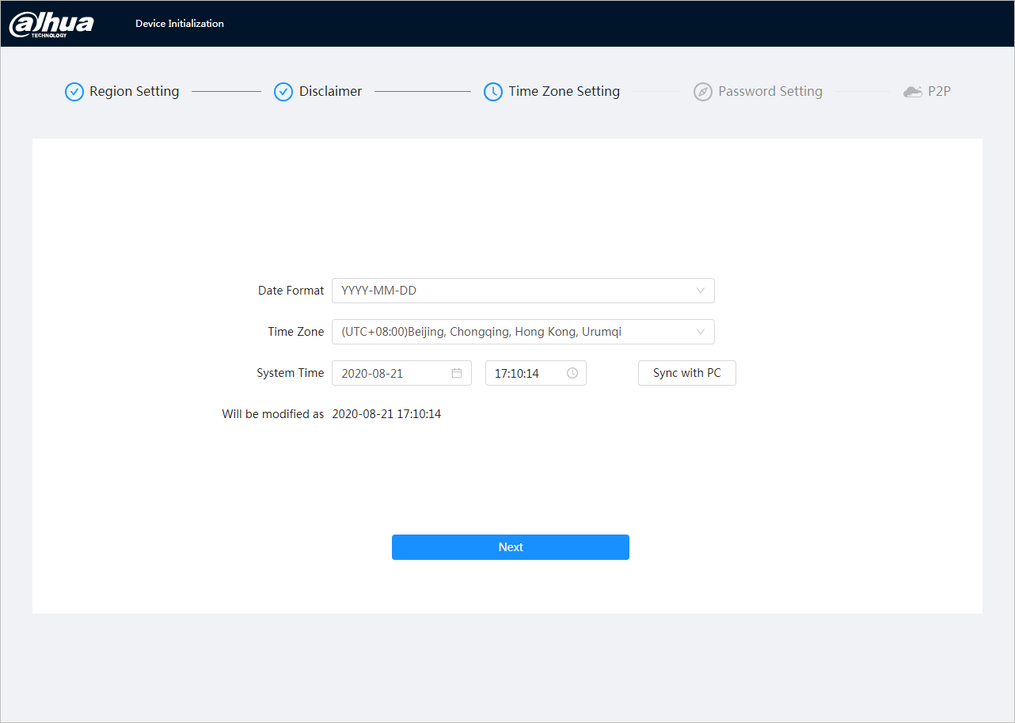

Step 4:Configure the time parameters, and then click Next.

Figure:password settings

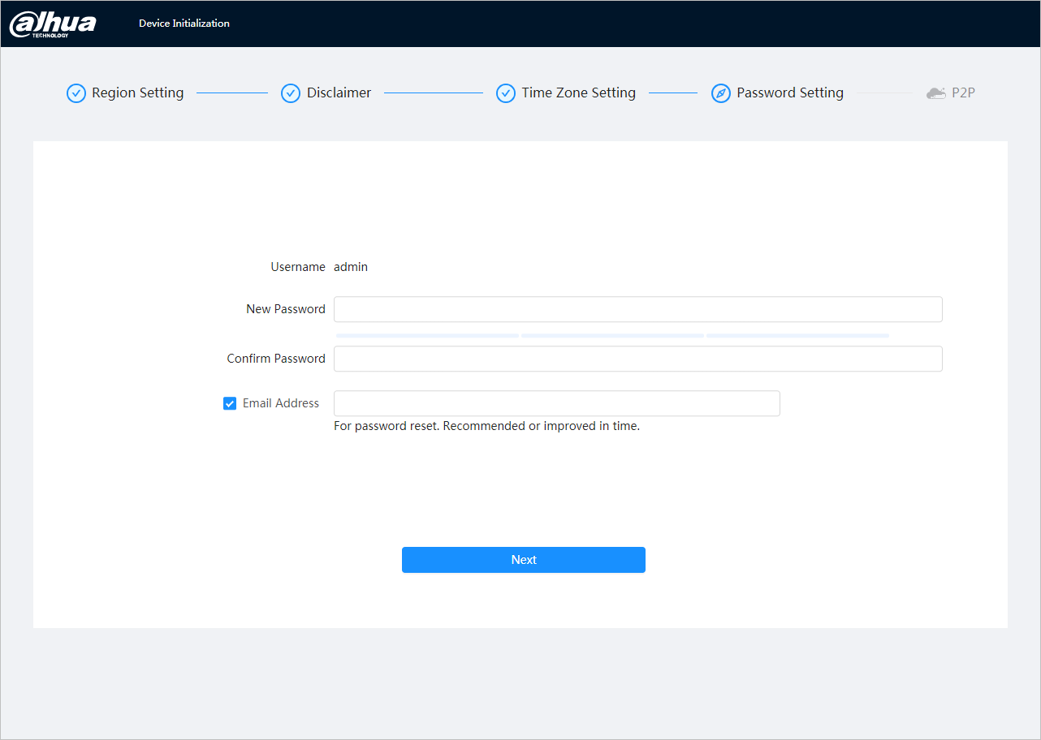

Step 5:Set the password for the administrator account.

Board:password setting description

| **Parameter** | **Description** |
| --- | --- |
| Username | The default username is admin. |
| Password | The password must consist of 8 to 32 non-empty characters and contain at least two types of characters including uppercase, lowercase, numbers, and special characters (excluding ' " ; : &). Please set a password with a high level of security according to the password strength notice. |
| Confirm Password |
| Saved Email | Enter an email address to reset your password and it will be selected by default.  When you need to reset the administrator account password, a password reset security code will be sent to the saved email address. |

Step 6:Click Next, then the P2P interface will appear.

Figure–P2P

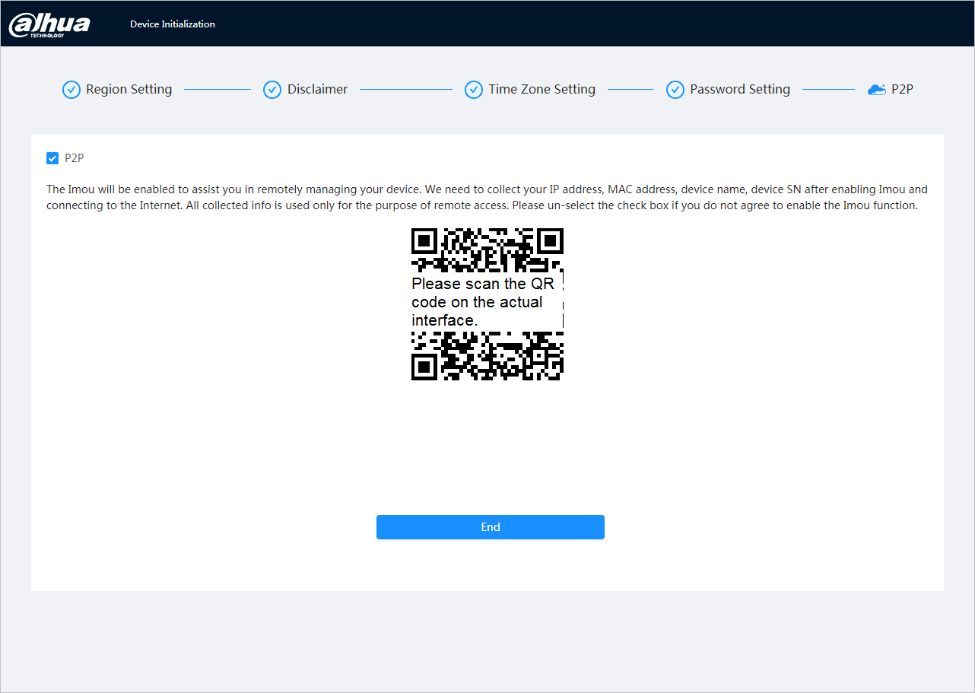

Scan the QR code on the real screen.

# Access

## Sign in to the device

This section explains how to log in and out of the web interface. This section takes the Chrome browser as an example.



* You must start the camera before logging in to the web interface. For details, see"‎2 Initialization of thedevice".
* When starting the camera, keep the PC IP and device IP in the same network.
* Follow the instructions to download and install the first login plugin.

Step 1:Open the Chrome browser, enter the camera's IP address (192.168.1.108 by default) in the address bar and press Enter.

Step 2:Enter the username and password.

The username is admin by default.



Click Forgot your password? (Forgot password?) to reset the password via the email address that was set at startup. For details, see "‎3.2 Reset thepassword"

Figure–Login

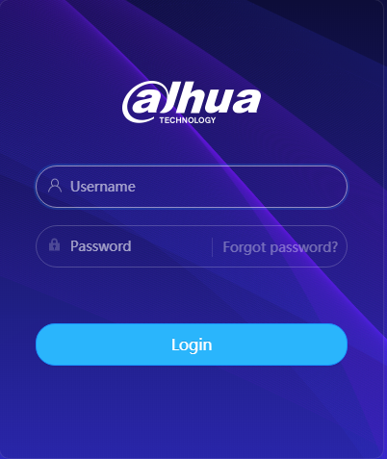

Step 3:Click Login.

The Live interface will appear. Click onin the upper left corner of the interface to bring up the main interface.



To log in for the first time, install the plugin by following the instructions on the screen.

Figure–Main screen

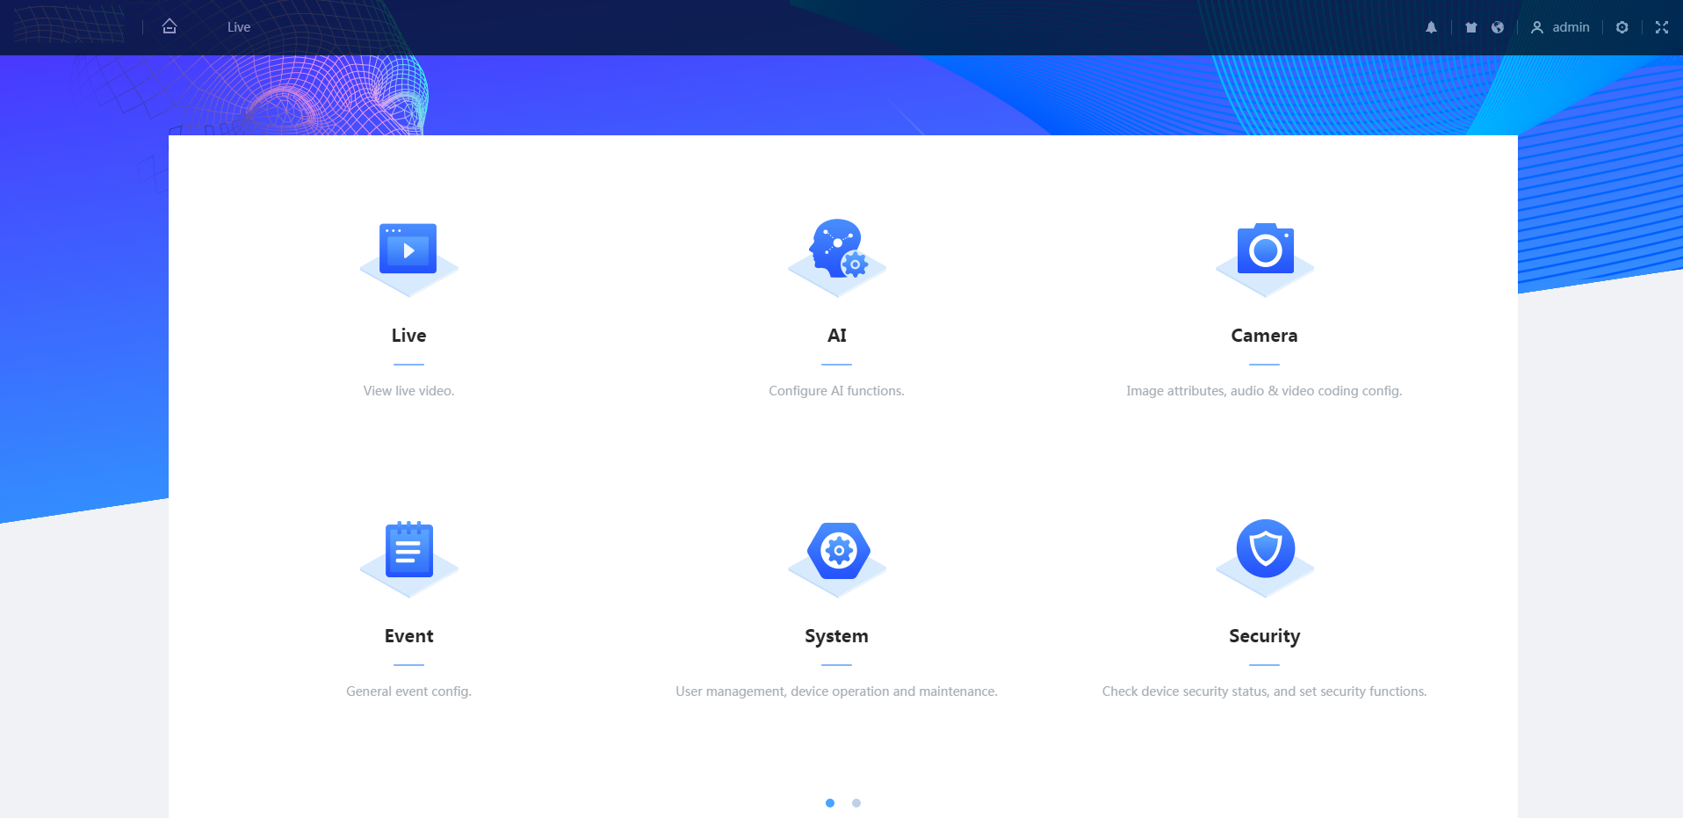

Live: View the monitoring image in real time.

AI: Set the camera's AI functions.

Camera: Set camera parameters, including image parameters, encoder parameters, and audio parameters.

Event: Configure general events, including alarm binding exception, video detection, and audio detection.

System: Configure system parameters, including general, date and time, account, security, PTZ settings, default, import/export, remote, auto maintenance and update.

Security: Check the device security status and configure security features.

Recording: Play or download recorded videos.

Image: Play or download image files.

Report: Find the AI ​​Events Report and System Report.

## Reset your password

When you need to reset the administrator account password, a security code will be sent to the email address you entered, which can be used to reset the password.

Previous requirements

You have enabled the password reset service****> System (System) > Account (Account) > User (User).

Procedure

Step 1:Open the Chrome browser, enter the device's IP address in the address bar, and then press the Enter key.

Figure–Login



Step 2:Click Forgot your password? (Forgot password?) to reset the password via the email address that was set at startup.

Figure–Login

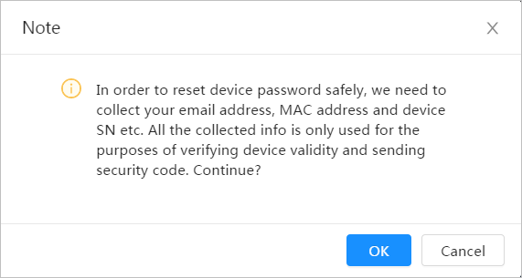

# Straight

This section introduces the interface design and function configuration.

## Live Interface

Sign in or click the Live tab.



The interface may vary according to different models and the actual interface shall prevail.

Figure:live (single channel)

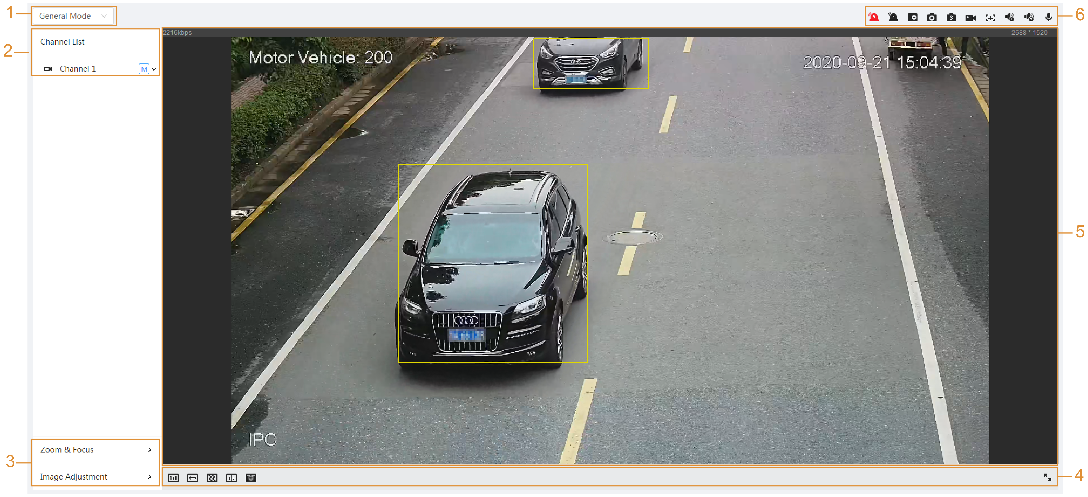

Figure:live (multichannel)

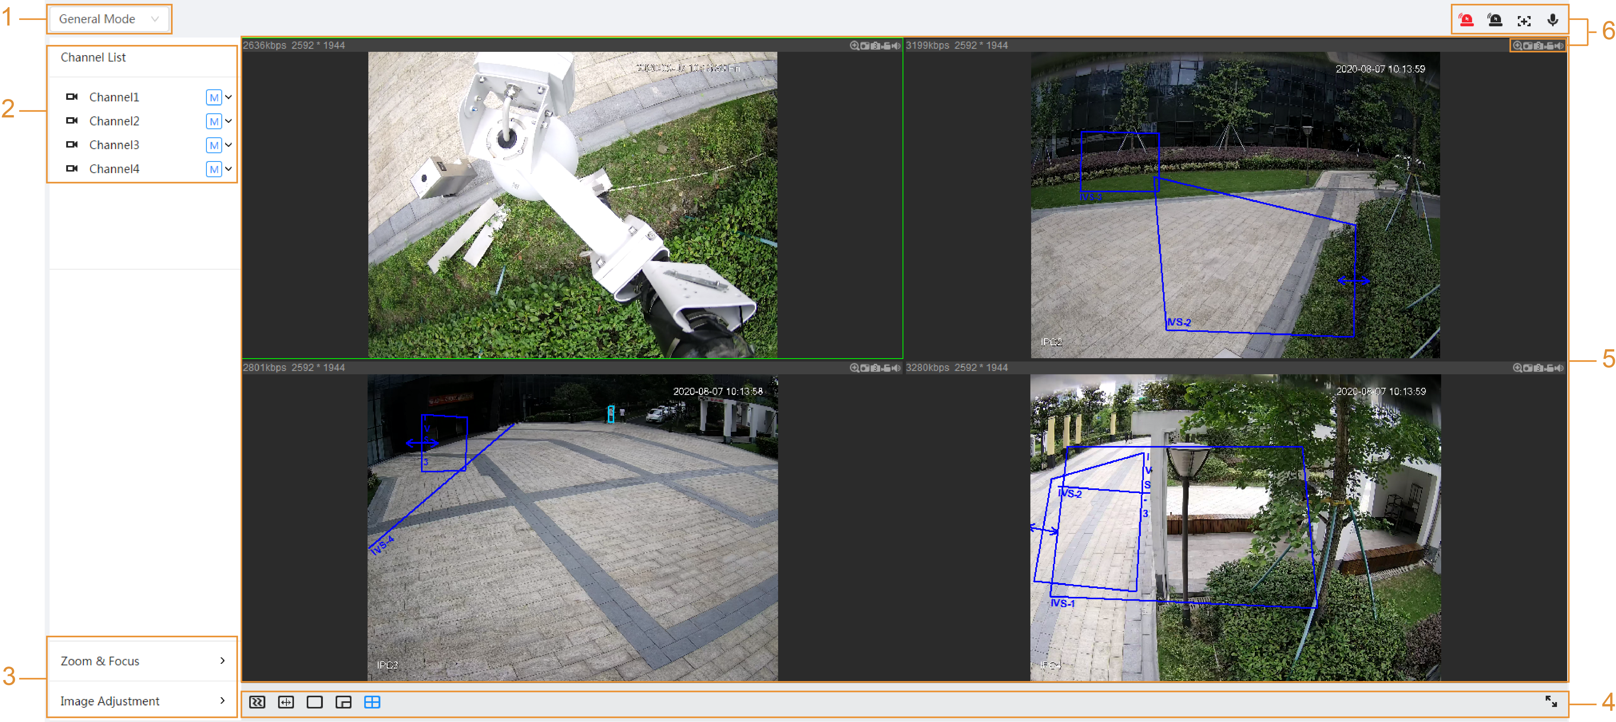

Board:function bar description

| **No.** | **Function** | **Description** |
| --- | --- | --- |
| 1 | Display mode | You can select the display mode between General Mode and Face Mode. |
| 2 | Channel list | Shows all channels. You can select the channel as needed and set the broadcast type. |
| 3 | Image adjustment | Adjustment operations in live viewing. |
| 4 |
| 5 | Live viewing | Shows the monitoring image in real time. |
| 6 | Live View Function Bar | Functions and operations in live viewing. |

## Encoding settings

Click onand then select the stream as needed.

Figure:coding bar

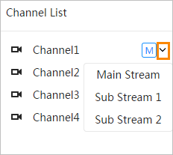

* **Main transmission:**It has great bit and image transmission value with high resolution, but also requires large bandwidth. This option can be used for storage and monitoring.
* **Secondary transmission:**It has a small bit rate and smooth image, and requires less bandwidth. This option is typically used to replace the main stream when bandwidth is not sufficient.
* means the current stream is the main stream;means the current stream is substream 1;means the current stream is sub stream 2.

# Settings

This section presents the basic settings of the camera, including Network, Event and System settings.

## Grid

This section presents the network configuration.

### **TCP/IP**

You can configure the IP address and DNS (Domain Name System) server and so on according to network planning.

Previous requirements

The camera has connected to the network.

Procedure

Step 1:Select****> Network (Network) > TCP/IP (TCP/IP).

Figure–TCP/IP

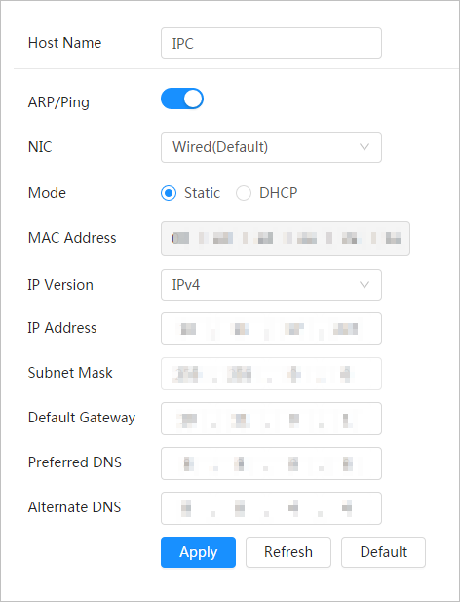

Step 2:Configure TCP/IP parameters.

Board:description of TCP/IP parameters

| **Parameter** | **Description** |
| --- | --- |
| Hostname | Enter the host name; the maximum length is 15 characters. |
| ARP/Ping | Click onto enable ARP/Ping and configure the IP address service. Obtain the MAC address of the camera so you can change and configure the device's IP address with the ARP/ping command.  This feature is enabled by default. During the reboot, you will have no more than 2 minutes to configure the device's IP address using a ping packet with a certain length; The server will shut down within 2 minutes or shut down immediately after the IP address is set successfully. If not enabled, the IP address cannot be configured with the ping packet.  **Demonstration of how to configure the IP address with ARP/Ping.**   1. Keep the camera to be configured and the PC within the same local network, and then obtain a usable IP address. 2. Obtain the camera's MAC address from the device label. 3. Open the command editor on the PC and enter the following command. 4. Restart the camera. 5. Check the PC command line; If the informational message Reply from 192.168.0.125… (Reply from 192.168.0.125…) appears, the configuration is successful and you can turn off the camera. 6. Enter http://(IP Address) in the browser address bar to log in. |
| NIC | Select the Ethernet card to be configured and the default is Wired. |
| Mode | The way the camera obtains the IP:  ● **Static**  Configure the IP Address, Subnet Mask, and Default Gateway manually, and then click Save; The login interface will appear with the configured IP address.  ● **DHCP**  When there is a DHCP server on the network, select DHCP and the camera will obtain the IP address automatically. |
| MAC address | Shows the MAC address of the host. |
| IP version | Select IPv4 or IPv6. |
| IP adress | When you select Static in Mode, enter the IP address and subnet mask you need.     * IPv6 does not have a subnet mask. * The default gateway must be on the same network segment as the IP address. |
| Subnet mask |
| Default access portal |
| Preferred DNS | Preferred DNS IP address |
| Alternative DNS | Alternate DNS IP Address |

Step 3:Click on Apply.

### **Port**

Configure the port numbers and the maximum number of users (includes web, platform client, and mobile phone client) that can connect to the device simultaneously.

Step 1:Select****> Network (Network) > TCP/IP (TCP/IP).

Figure:port

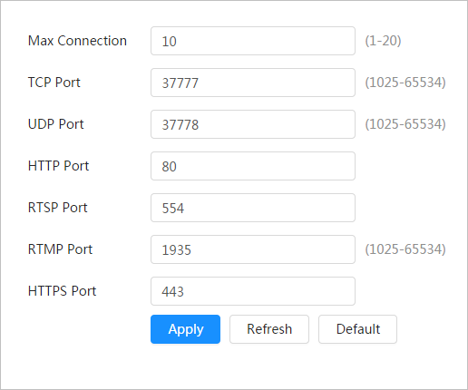

Step 2:Configure the port parameters.



* 0–1024, 1900, 3800, 5000, 5050, 9999, 37776, 37780–37880, 39999, 42323 are occupied for specific uses.
* Do not use the same value of any other port during port configuration.

Board:port parameter description

| **Parameter** | **Description** |
| --- | --- |
| Maximum connections | The maximum number of users (web client, platform client, or mobile phone client) that can connect to the device simultaneously. The default value is 10. |
| TCP port | Transmission control protocol port. The default value is 37777. |
| UDP port | User datagram protocol port. The default value is 37778. |
| HTTP port | Hypertext transfer protocol port. The default value is 80. |
| RTSP port | * Real-time streaming protocol port, and the default value is 554. If you play live viewing with QuickTime, VLC, or a Blackberry smartphone, the following URL format is available. * When the URL format requires RTSP, you must specify the channel number and bitstream type in the URL, and also the username and password if necessary.   URL format example:  rtsp://username:password@ip:port/cam/realmonitor?channel=1&subtype=0  Among that:   * Username: The username, which would be admin. * Password: The password, which would be admin. * IP: The IP of the device, which would be 192.168.1.112. * Port: Leave it if the value is the default value 554. * Channel: The channel number, starting at 1. For example, if you are using channel 2, then channel = 2. * Subtype: The type of bit transmission; 0 means primary stream (subtype = 0) and 1 means secondary stream (subtype = 1).   Example: If you need the secondary stream of channel 2 from a given device, the URL should be:  rtsp://admin: admin@10.12.4.84 :554/cam/realmonitor?channel= 21&=1  If the username and password are not required, the URL can be:  rtsp://ip:port/cam/realmonitor?channel=11&=0 |
| RTMP port | Real-time messaging protocol. The port that RTMP provides service. It is 1935 by default. |
| HTTPS port | HTTPS communication port. It is 443 by default. |

Step 3:Click on Apply.



The Max Connections setting (Max Connection) takes effect immediately, and the others will take effect after reboot.

### **Email**

Configure the email parameter and enable email binding. The system sends an email to the defined address when the corresponding alarm is activated.

Step 1:Select****> Network (Netwok) > Email (Email).

Figure:email

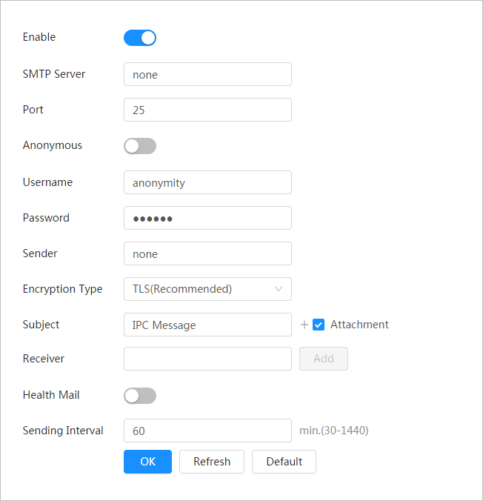

Step 2:Click onto enable the feature.

Step 3:Configure email parameters

Board:description of email parameters

| **Parameter** | **Description** | |
| --- | --- | --- |
| SMTP server | SMTP server address | For details, seeTable ‎5:4. |
| Port | The port number of the SMTP server. |
| Username | The SMTP server account. |
| Password | The SMTP server password. |
| Anonymous | Click onand the sender information will not be displayed in the email. | |
| Sender | Sender email address. | |
| Encryption type | Select between None SSL and TLS.    For details, seeTable ‎5:4. | |
| Qualification | Enter a maximum of 63 characters in Chinese, English, and Arabic numerals. Click onto select the title type, including Device Name, Device ID, and Event Type; You can set a maximum of 2 titles. | |
| Attached data | Check the checkbox to be able to attach files to the email. | |
| Addressee | * Recipient's email address. Supports 3 addresses maximum. * After entering the recipient's email address, the Test button will appear. Click Test to test whether emails can be sent and received correctly. | |
| verification email | The system sends a test email to verify that the connection has been configured correctly. Click onand set the Sending Interval, and then the system will send the test email at the set interval. | |

For the configuration of the main mailboxes, see.Table 5:4.

Board:Mailbox settings description

| **mailbox** | **SMTP server** | **Authentication** | **Port** | **Description** |
| --- | --- | --- | --- | --- |
| gmail | smtp.gmail.com | SSL | 465 | * You need to have the SMTP service activated in your mailbox. * The authentication code is required. The email password is not applicable.     Authentication code: The code you receive when you enable the SMTP service. |
| TLS | 587 |

Step 4: Click on Apply.

### **Basic service**

Configure basic services to improve network and data security.

Step 1:Select****> Network > Basic Service.

Figure:basic service

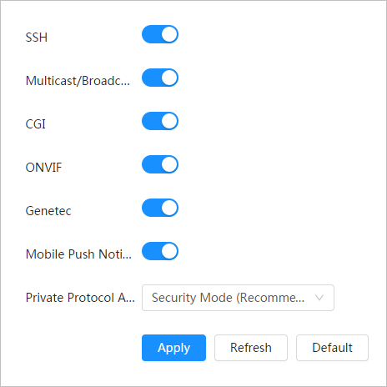

Step 2:Enable basic service based on actual needs.

Board:description of basic parameters of the service

| **Function** | **Description** |
| --- | --- |
| SSH | You can enable SSH authentication to manage security. |
| Multicast/broadcast search | Enable this function, and then when multiple users are viewing the device's video image simultaneously over the network, they can find your device with the multicast/broadcast protocol. |
| CGI | Enable the feature and then other devices can access it through this service. The feature is enabled by default. |
| Onvif |
| Genetec |
| *******Push mobile notifications******* | Enable this feature and then the system will send the snapshot that was taken when the alarm was triggered to your phone, this is enabled by default. |
| Private protocol authentication mode | Select the authentication mode between Security Mode and Compatible Mode. Safety mode is recommended. |

Step 3:Click on Apply.

## Event

This section takes alarm input, for example, to present alarm linkage configuration.

Figure:alarm event configuration

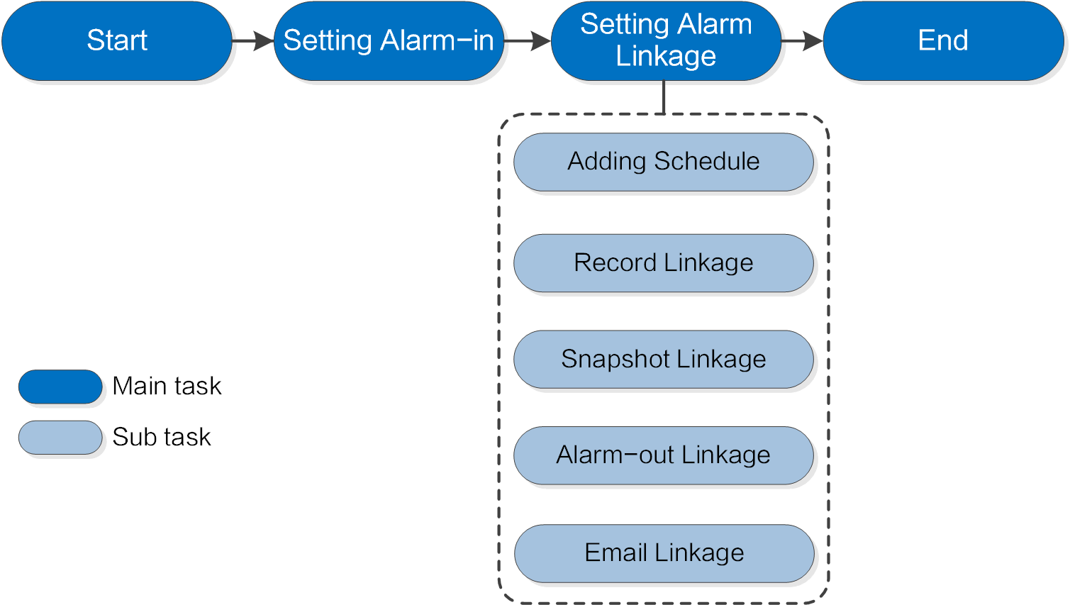

Alarm input configuration

Email Linking

Alarm output linkage

Linking snapshots

Recording Link

Add schedule

Finish

Set alarm linkage

Start

Main task

Secondary task

### **Alarm input configuration**

When the device connected to the alarm input port triggers an alarm, the system performs the set alarm linkage.

Step 1:Select****> Event (Event) > Alarm (Alarm).

Step 2:Click onnext to Enable to enable alarm linking.

Figure–Alarm linkage

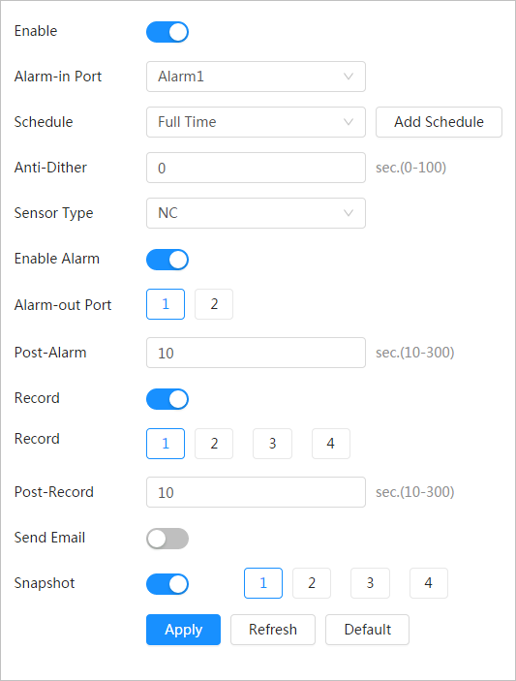

Step 3:Select an alarm input port and sensor type.

● Sensor type: NO or NC.

● Anti-fluctuation:Only log one alarm event during the anti-interpolation period.

Step 4:Select the schedule and arming periods and alarm linkage action. For details, see "‎5.2.2 Set alarm linkage"

If the existing schedules cannot meet the scene requirement, you can click Add Schedule to add a new schedule. For details, see "‎5.2.2.1 Add schedule"

Step 5:Click on Apply.

### **Set alarm linkage**

When configuring alarm events, select alarm links (such as log, snapshot). When the corresponding alarm is activated in the configured arming period, the system will issue an alarm.

Select****> Event (Event) > Alarm (Alarm),next to Enable to enable alarm linking.

Figure–Alarm linkage



#### **Add schedule**

Establish arming periods. The system only performs the corresponding linking action in the configured period.

Step 1:Click Add Schedule next to Schedule.

Figure:programming

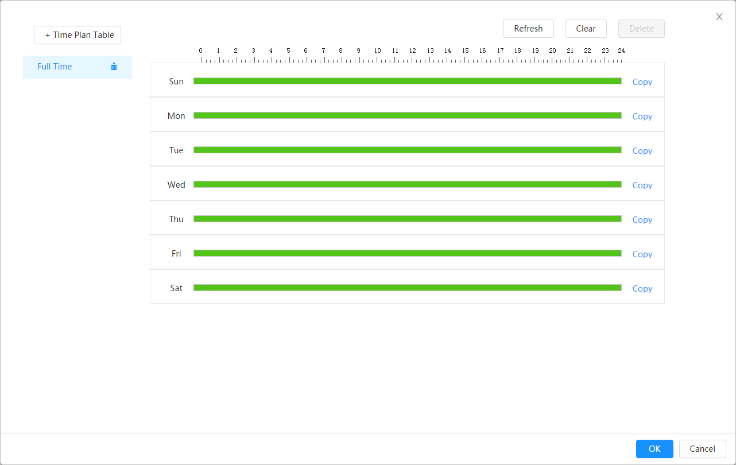

Step 2:Press and drag the left mouse button over the timeline to set arming periods. Alarms will be triggered in the time period in green on the timeline.

* Click Copy next to a day and select the days you want to copy to in the prompt interface; You can copy the settings to the selected days. Select the Select All check box to select every day to copy the settings.
* You can set 6 time periods per day.

Step 3:Click on Apply.

Step 4:(Optional) Click Time Plan Table to add a new time plan table.

Can:

* Double-click the table name to edit it.
* Click onto delete history as needed.

#### **Recording Link**

The system can link the recording channel when an alarm event occurs. After the alarm, the system stops recording after a long period of time according to the Post-Record setting.

Previous requirements

* Once the corresponding alarm type (Normal, Motion, or Alarm) is enabled, the recording channel links the recording.
* Enable auto recording mode, recording linkage will be applied.

Set recording linkage

In the Alarm interface, clickTo enable record linkage, select the channel as necessary and set Post-Record to set alarm linkage and recording delay.

Once Post-Record is set, alarm recording continues for an extended period after the alarm ends.

Figure:recording link

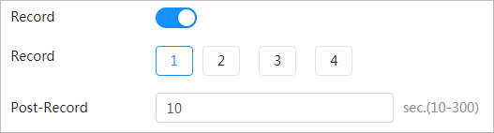

#### **Linking snapshots**

Once snapshot linking is set up, the system can activate the alarm and automatically take photos when an alarm is triggered.

Previous requirements

Once the corresponding alarm type (Normal, Motion, or Alarm) is enabled, the snapshot channel links the image capture.

Set recording linkage

In the Alarm interface, clickto enable snapshot linking and select the channel as necessary.

Figure:snapshot link



#### **Alarm output linkage**

When an alarm is triggered, the system can automatically link with the alarm output device.

In the Alarm interface, clickTo enable alarm output linking, select the channel as necessary, and then configure Post alarm.

When the alarm delay is set, the alarm continues for an extended period after the alarm ends.

Figure:alarm output link

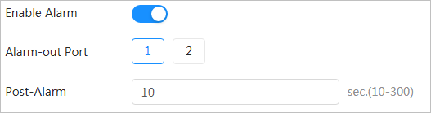

#### **Email Linking**

When an alarm is triggered, the system will automatically send an email to users.

Email binding takes effect only when SMTP is configured. For details, see "‎5.1.3 Email"

Figure:email link



## System

This section presents the system settings, including general, date and time, account, security, PTZ settings, default, import/export, remote, auto maintenance and update.

### **General**

#### **Essential**

You can set the device name, language and video standard.

Step 1:Select****> System (System) > General (General) > Basic (Basic).

Figure:essential

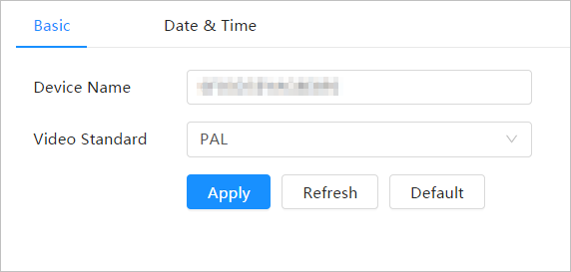

Step 2:Configure general parameters

Board:description of general parameters

| **Parameter** | **Description** |
| --- | --- |
| Name | Enter device name |
| Video standard | Select the video standard between PAL and NTSC. |

Step 3:Click on Apply.

#### **Date and Time**

You can set the date and time format, time zone, current time, DST (daylight saving time), or NTP server.

Step 1:Select****> System > General > Basic > Date & Time.

Figure:Date and Time

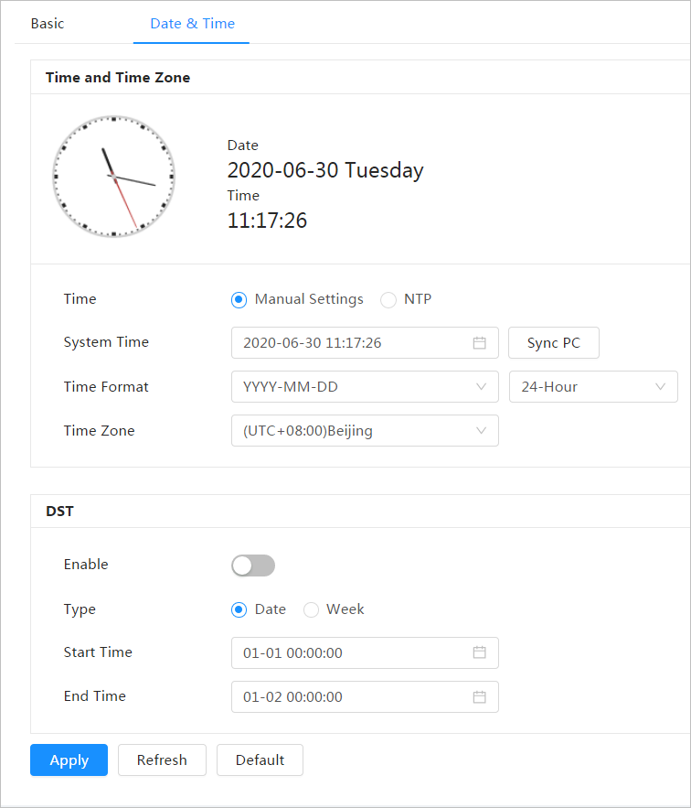

Step 2:Configure date and time parameters.

Board:description of date and time parameters

| **Parameter** | **Description** |
| --- | --- |
| Date format | Set the date format. |
| Hour | ● **Manual configuration:**configure the parameters manually.  ● **NTP:**When you select NTP, the system synchronizes the time with the Internet server in real time.  You can also enter the IP address, time zone, port, and range of a PC with NTP server to use NTP. |
| Time format | Set the time format. You can select between 12 hours (12-Hour) or 24 hours (24-Hour). |
| Time zone | Set the time zone the camera is in. |
| Current time | Set the system time.  Click Sync PC and the system will adopt the PC time. |
| DST | Enable DST as needed.  Click on, and set the start and end time of daylight savings time with Date or Week. |

Step 3:Click on Apply.

### **Account**

You can manage users, such as adding, deleting, or editing them. Users include administrators, added users, and ONVIF users.

User and group management is only available for administrator users.

* The maximum length of the user or group name is 31 characters, consisting of number, letter, underscore, hyphen, period, and @.
* The password must consist of 8 to 32 non-empty characters and contain at least two character types including uppercase, lowercase, numbers, and special characters (excluding ' " ; : &).
* You can have a maximum of 18 users and 8 groups.
* You can manage users through a single user or group and no duplicate usernames or group names are allowed. A user can only be in one group, and users in the group can have permissions within the group's authority range.
* Online users cannot edit their own permission.
* There is a default administrator who has the maximum authorization.
* Select Anonymous Login, and then log in with just the IP address instead of the username and password. Anonymous users only have preview authorization. During anonymous login, click Logout and then you can log in with another username.

#### **User**

##### **Add users**

You are an administrator user by default. You can add users and configure different permissions.

Step 1:Select****> System (System) > Account > (Account) User (User).

Figure:user

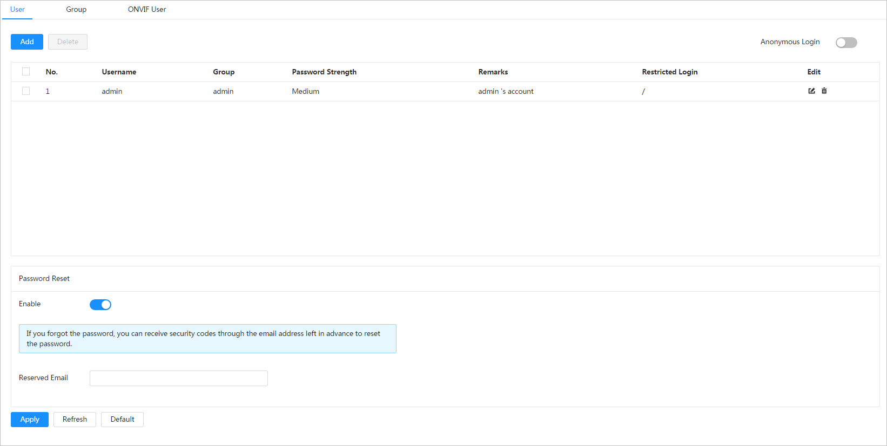

Step 2:Click Add.

Figure:add user (system)

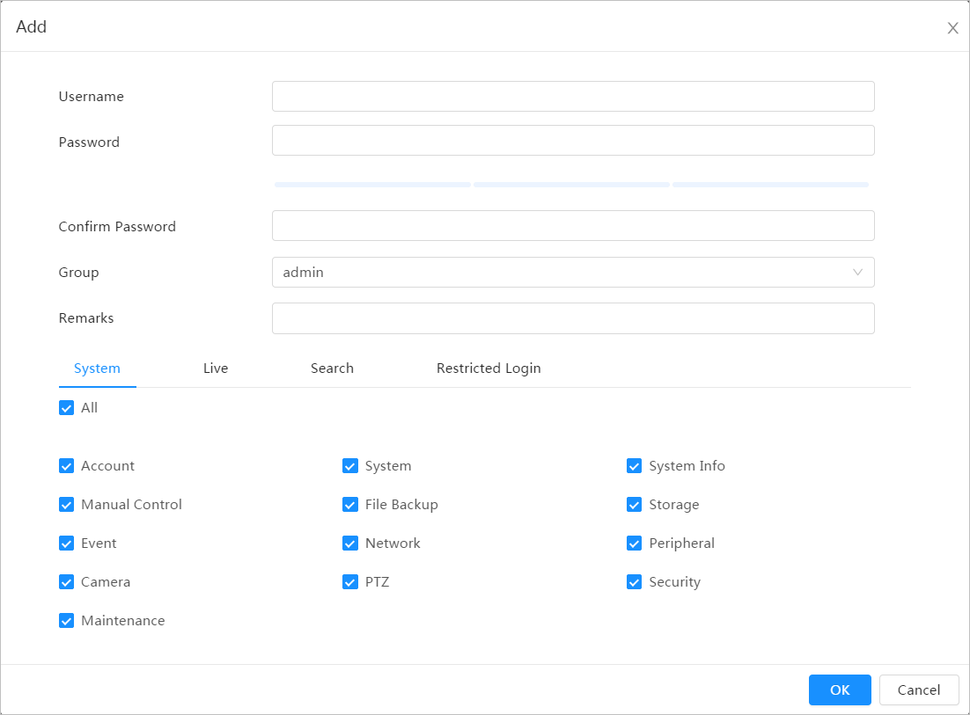

Figure:add user (restricted login)

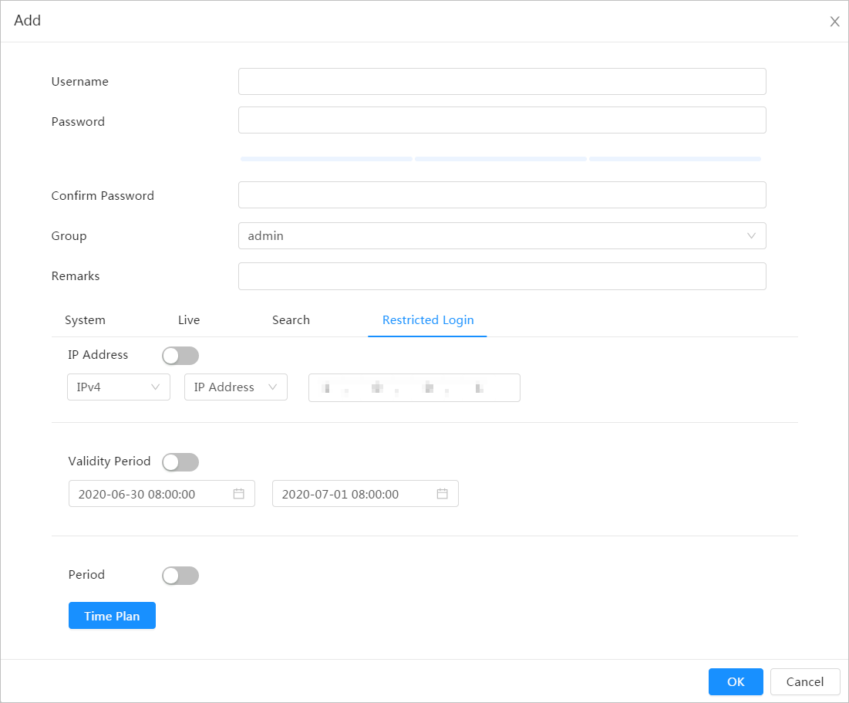

Step 3:Configure user parameters

Board:description of user parameters (1)

| **Parameter** | **Description** |
| --- | --- |
| Username | Unique user identification. You cannot use the existing username. |
| Password | Enter the password and confirm it again.  The password must consist of 8 to 32 non-empty characters and contain at least two character types including uppercase, lowercase, numbers, and special characters (excluding ' " ; : &). |
| Confirm Password |
| Cluster | The group to which the users belong. Each group has different permissions. |
| Observation | Describe the user. |
| System | Select permissions as necessary.    It is recommended to grant fewer permissions to regular users than to premium users. |
| Straight | Select the live viewing permission for the user to be added. |
| Look for | Select the search permission for the user to be added. |
| Restricted login | Set the PC address that allows the user to log in to the camera and the validity period and time range. You can log in to the web interface with the IP set in the time range set as the validity period.   * IP Address: You can log in to the web through PC with the set IP. * Validity period: You can log in to the website within the set validity period. * Time Range: You can log in to the web in the set time range.   Set as follows   1. IP Address: Enter the IP address of the host to be added. 2. IP Segment: Enter the start address and end address of the host to be added. |

Step 4:Click on Apply.

The newly added user appears in the username list.

Related operations

* Click onto edit the password, group, note, or permissions.



For administrator account, you can only edit the password.

* Click onto delete the added users. The administrator user cannot be deleted.



The administrator account cannot be deleted.

##### **Reset your password**

Enable the feature and you can reset your password by clicking Forgot your password? (Forget password?) in the login interface. For details, see  
"‎3.2 Reset your password"

Step 1:Select****> System (System) > Account > (Account) User (User).

Figure:user



Step 2:Click onnext to Enable in Reset Password  
(Password Reset).

If the feature is not enabled, you can only reset the password by resetting the camera.

Step 3:Enter the reserved email address.

Step 4:Click on Apply.

#### **ONVIF user**

You can add, remove ONVIF users and change their passwords.

Step 1:Select****> System > Account > ONVIF User(ONVIF User).

Figure–ONVIF user

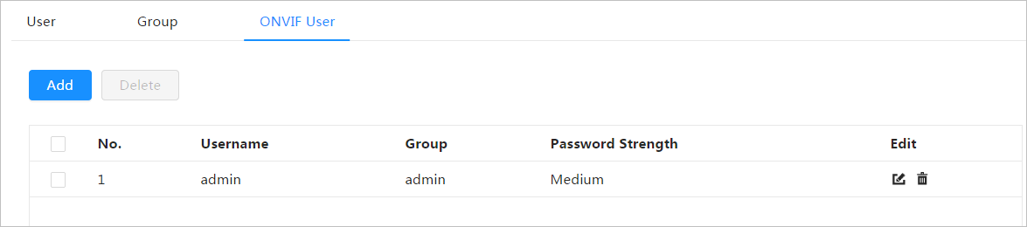

Step 2:Click Add.

Figure:add ONVIF user

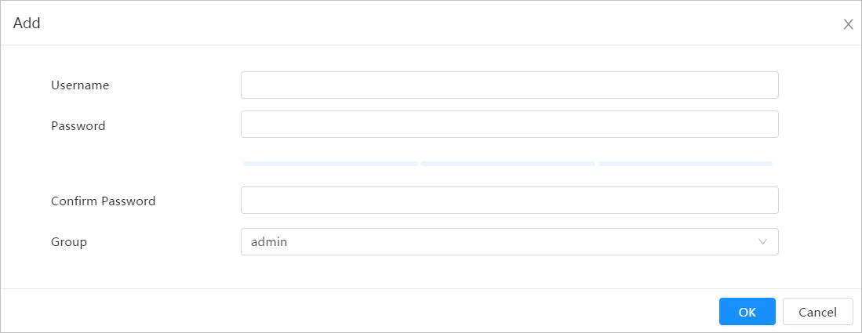

Step 3:Configure user parameters

Board:description of ONVIF user parameters

| **Parameter** | **Description** |
| --- | --- |
| Username | Unique user identification. You cannot use the existing username. |
| Password | Enter the password and confirm it again.  The password must consist of 8 to 32 non-empty characters and contain at least two character types including uppercase, lowercase, numbers, and special characters (excluding ' " ; : &). |
| Confirm Password |
| Group name | The group to which the users belong. Each group has different permissions. |

Step 4:Click on Accept (OK).

The newly added user appears in the username list.

Related operations

* Click onto edit the password, group, note, or permissions.



For the administrator account, you can only change the password.

* Click onto delete the added users. The administrator user cannot be deleted.



The administrator account cannot be deleted.

### **Managers**

#### **Requirements**

To ensure that the system works correctly, perform the following actions:

* Check surveillance footage regularly.
* Regularly delete information from users and user groups that are not used frequently.
* Change your password every three months. For details, see "‎5.3.2 Account"
* View and analyze system logs, and fix errors in a timely manner.
* Back up system settings regularly.
* Restart your device and delete old files regularly.
* Please update the firmware accordingly.

#### **Maintenance**

You can restart the system manually and set the automatic restart time, in addition to automatically deleting old files. This feature is disabled by default.

Step 1:Select****> System (System) > Account (Account) > Maintenance (Maintenance).

Figure:maintenance

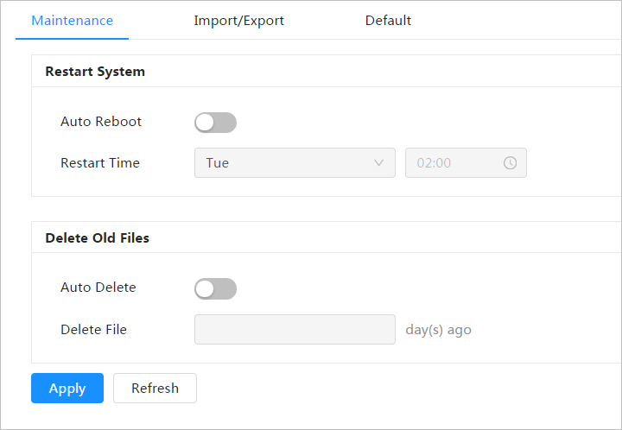

Step 2:Set the parameters for automatic maintenance.

* Click onnext to Auto Reboot in Restart System and set the reboot time; The system automatically restarts as the set time every week.
* Click onnext to Auto Delete in Delete Old Files and set the time; The system automatically deletes old files according to the set time. The time range is 1 to 31 days.



When you enable and confirm the Auto Delete function, deleted files cannot be restored. Carry out the procedure carefully.

Step 3:Click on Apply.

#### **Import Export**

* Export the system configuration file to backup system configuration.
* Import the system configuration file to perform quick configuration or recover system settings.

Step 1:Select****> System (System) > Account (Account) > Import/Export (Import/Export).

Figure–Import Export

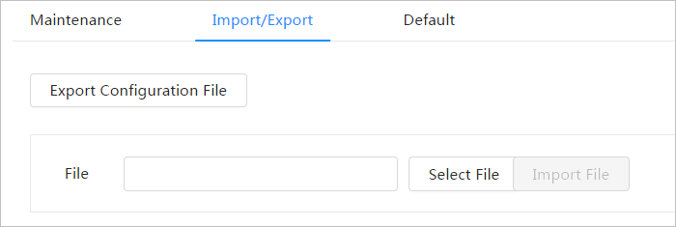

Step 2:Import and export.

* Import: Select the local configuration file and click Import File to import the local system configuration file to the system.
* Export: Click Export Configuration File to export the system configuration file to local storage.

#### **Predetermined**

Restore the device to default settings or factory settings.

This feature will restore the device to default settings or factory settings.

Select****> System (System) > Account > (Account) Default (Defautl).

* Click Default, then all settings except IP address and account will be reset to default values.
* Click Factory Default and all settings will be reset to factory settings.

Figure:predetermined

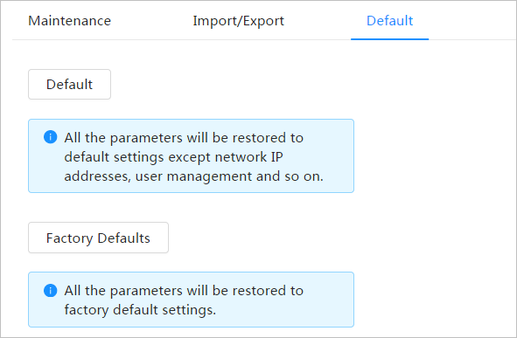

### **Update**

Updating to the latest version may improve camera features and stability.

If an incorrect update file has been used, restart the device; Otherwise, some functions may not work properly.

Step 1:Select****> System (System) > Update (Upgrade).

Figure :update

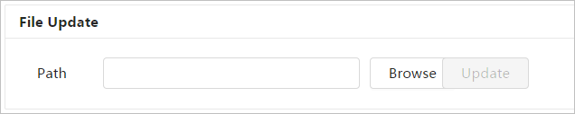

Step 2:Click Browse and then upload the update file.

The update file must be a .bin file.

Step 3:Click Upgrade.

The update will start running.

**Appendix 1 Cybersecurity recommendations**

Cybersecurity is more than a buzzword: it's something that belongs to all devices that are connected to the Internet. IP video surveillance is not immune to cyber risks, but taking basic steps to protect and harden networks and network-connected devices will make them less susceptible to attacks. Below are some tips and recommendations on how to create a more secure security system.

**Mandatory measures you must take for basic computer network security:**

1. **Use strong passwords**

See the following tips for setting passwords:

The length cannot be less than 8 characters;

Include at least two types of characters: upper and lower case letters, numbers, and symbols;

Do not use the account name or account name backwards.

Do not use continuous characters, such as 123, abc, etc.;

Do not use continuous repeating characters, such as 111, aaa, etc.;

1. **Update firmware and client software promptly**

As per standard procedure in the technology industry, we recommend that you keep the firmware of your equipment (such as NVR, DVR, IP camera, etc.) updated to ensure that the system is equipped with the latest patches and security fixes. When the computer is connected to the public network, it is recommended to enable the "automatic update check" function to obtain timely information about firmware updates released by the manufacturer.

We suggest that you download and use the latest version of the client software.

**Recommended steps to improve your computer's network security:**

1. **Physical protection**

We suggest that you physically protect your equipment, especially storage devices. For example, place the computer in a special computer room and closet and implement proper access control permission and key management to prevent unauthorized personnel from physically accessing the computer and damaging the hardware, unauthorized connection to computers. removable (such as a USB flash disk, serial port), etc.

1. **Change passwords periodically**

We suggest that you change your passwords periodically to reduce the risk of passwords being guessed or cracked.

1. **Set and promptly update password reset information**

The device supports the password reset function. Configure information related to timely password resets, including password protection questions and the end user's email address. If the information changes, please modify it immediately. When setting password protection questions, we suggest that you do not use those that can be easily guessed.

1. **Enable account lock**

The account lock feature is enabled by default, and we recommend that you keep it enabled to ensure account security. If an attacker tries to log in with the wrong password multiple times, the corresponding account and source IP address will be blocked.

1. **Change HTTP and other default service ports**

We suggest that you change the default HTTP and other service ports to any series of numbers between 1024 and 65535, reducing the risk that outsiders can guess which ports you are using.

1. **Enable HTTPS**

We suggest that you enable HTTPS so that it visits the web service over a secure communication channel.

1. **MAC address binding**

We recommend that you bind the IP and MAC address of the gateway to the computer, reducing the risk of ARP redirection.

1. **Assign accounts and privileges reasonably**

According to business and management requirements, reasonably add users and assign them a minimum set of permissions.

1. **Disable unnecessary services and choose safe modes**

If they are not necessary, it is recommended to disable some services such as SNMP, SMTP, UPnP, etc., to reduce the risks.

If necessary, it is strongly recommended that you use safe modes, including but not limited to the following services:

SNMP: Select SNMP v3 and configure strong encryption passwords and authentication passwords.

SMTP: Select TLS to access the Mailbox server.

FTP: Select SFTP and set strong passwords.

AP Access Point: Select WPA2-PSK encryption mode and set strong passwords.

1. **Encrypted audio and video transmission**

If your audio and video data content is very important or sensitive, we recommend that you use the encrypted transmission function to reduce the risk of audio and video data theft during transmission.

Remember: Encrypted transmission will cause some loss in transmission efficiency.

1. **Secure audit**

Check online users: We suggest that you check online users periodically to see if anyone has logged in to the device without authorization.

Check device log: By checking the logs, you can know the IP addresses that have been used to log in to your devices and their key operations.

1. **Network log**

Due to the limited storage capacity of the computer, the log stored is limited. If you need to save the log for a long time, we recommend that you enable the network log function to ensure that important logs are synchronized with the network log server for tracking.

1. **Create a secure network environment**

To better ensure equipment security and reduce potential cyber risks, we recommend:

Disable the router's port mapping feature to prevent direct access to intranet devices from an external network.

Partition and isolate the network according to the real needs of the network. If there is no communication requirement between two subnets, we suggest that you use VLAN, network GAP and other technologies to partition the network, so as to achieve the effect of network isolation.

Establish 802.1x access authentication system to reduce the risk of unauthorized access to private networks.

Enable the IP/MAC address filtering feature to limit the range of hosts allowed to access the device.

|  |
| --- |
| HELPING CREATE A SAFER SOCIETY AND A SMARTER LIFESTYLE |
| ZHEJIANG DAHUA VISION TECHNOLOGY CO., LTD.  Address: No.1399 Bin'an Road, Binjiang District, Hangzhou, PR China | Website:[www.dahuasecurity.com](http://www.dahuasecurity.com)| Postal code: 310053  Email:[overseas@dahuatech.com](mailto:overseas@dahuatech.com)| Fax: +86-571-87688815 | Tel.: +86-571-87688883 |